Grade 1 Literacy Activities: June 1-5
Use Headsprout and try to complete 3 episodes during the week. (this is phonics work, which will help students with their reading)

Practice sight words or spelling words.

Read for at least 15 min each day.

Please send me a piece of your child’s writing each week. I will send feedback on what they have done well and what they could do to improve. (email me or message me on Class Dojo)

**This document has many, many active links to be viewed during the daily lessons. It would be best to use an active, online copy for day-to-day use, either via your email attachment or on https://missorchardsclass.weebly.com/

*** If you can print it and stick it on your fridge or bulletin board. Have your child check off each day, once completed. That way if you miss a day, you know where you left off.

It is my hope you find this helpful. Please keep in mind that this is not meant to be a burden and put any added pressure on your day-to-day routines. It is only being made available for those who wish to make use of it. If you have any questions, please let me know.

Have fun!

Grade 1 Literacy Activities: June 1-5

Tic-Tac-Toe Board
Try and complete 3 activities during the week to get a horizontal, vertical or diagonal line.

Challenge: see how many of these activities you can do this week.

Reading – decoding startegies | Reading - comprehension | Writing
watch video here  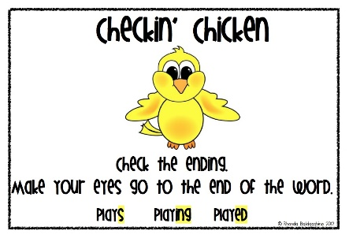 | Choose a book to read.  Try using some of decoding strategies when you come to a word you don’t know.  Remember you can do more than just stretch out the sounds. | Rhyming Words  write 3 words that rhyme with these words:  pin clump drain
Consonant blends  ‘L’ blend video  ‘R’ blend video  ‘S’ blend video | Read a book on Raz-kids. Before you start, press the record button. Now your teacher will be able to listen to it. | -ight Word Family  video 1 video 2  How many words can you print that belong in the –ight word family? Remember words in a words family have the same ending, just the beginning sound changes.  Can you print at least 3?  How about more than 3?
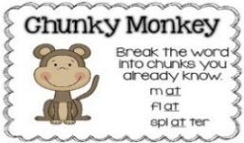  Watch the Chunky Monkey video  Watch the Chunk It video  Now find 3 unknown words in a book. Use chunking to help you figure out the word. | 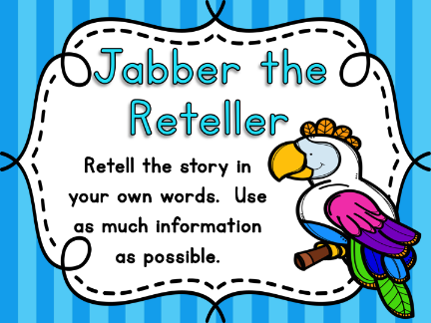  video | Write about a time you were excited.  Remember to try and answer the questions Who, What, Where, When & Why.

