Grade 1 Literacy Activities: June 8-12
Use Headsprout and try to complete 3 episodes during the week. (this is phonics work, which will help students with their reading)

Practice sight words or spelling words.

Read for at least 15 min each day.

Please send me a piece of your child’s writing each week. I will send feedback on what they have done well and what they could do to improve. (email me or message me on Class Dojo)

**This document has many, many active links to be viewed during the daily lessons. It would be best to use an active, online copy for day-to-day use, either via your email attachment or on https://missorchardsclass.weebly.com/

*** If you can print it and stick it on your fridge or bulletin board. Have your child check off each day, once completed. That way if you miss a day, you know where you left off.

It is my hope you find this helpful. Please keep in mind that this is not meant to be a burden and put any added pressure on your day-to-day routines. It is only being made available for those who wish to make use of it. If you have any questions, please let me know.

Have fun!

Grade 1 Literacy Activities: June 8-12

Tic-Tac-Toe Board
Try and complete 3 activities during the week to get a horizontal, vertical or diagonal line.

Challenge: see how many of these activities you can do this week.

Reading – decoding strategies | Reading | Writing
‘R’ controlled vowels  video for ‘ar’  video for ‘er, ir, ur’  video for ‘or’ | Making predictions  watch video here  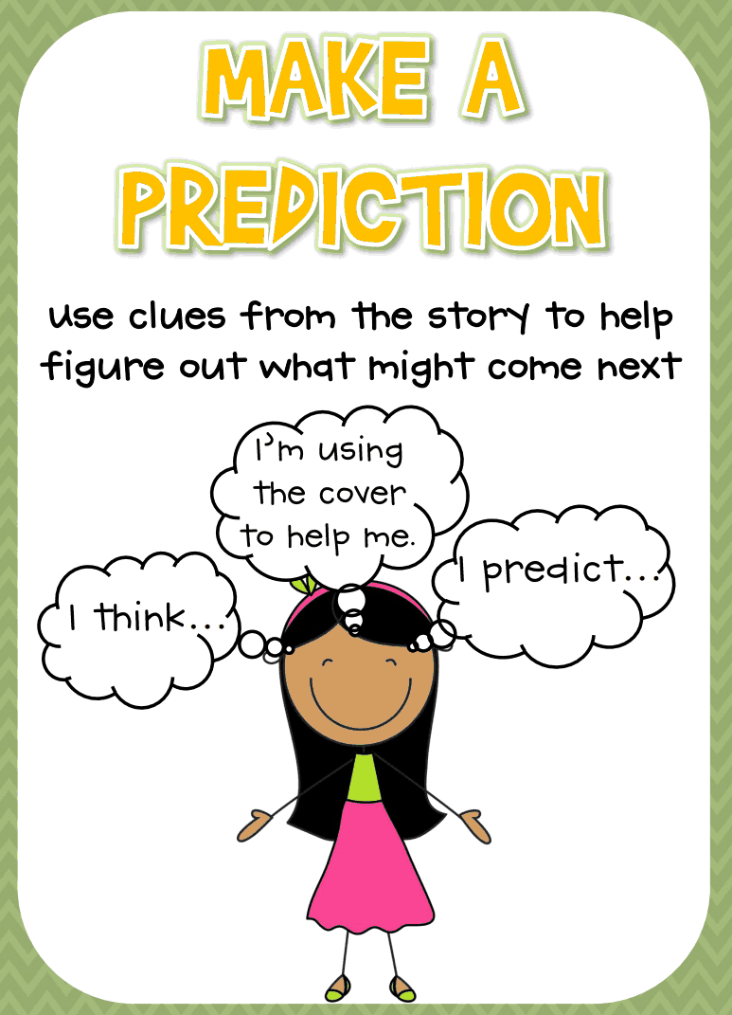 | Write about a fictional story of your choice. Be sure to include the characters, a problem and solution, and the setting.
3 letter blends  watch video here  Can you read these words?  spring shrimp  split straw  scrub thrill | Read a book on Raz-kids. Before you start, press the record button. Now your teacher will be able to listen to it. | Parts of a Sentence  watch video here  Now write about what fun things you hope to do this summer.  Remember to make sure your sentences include all 4 parts of a sentence.
Tryin’ Lion Reading strategy  watch video here  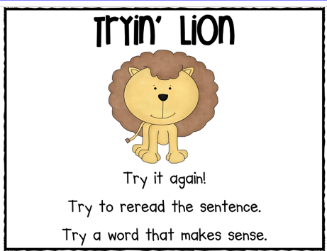  Now go read a book and use Trying’ Lion when you come to a word you don’t know. | Consonant Digraphs  watch video here  Now try reading these words:  bench short thank  chain math cash  when chin ship  what sharp where | What words can you make with the following letters:  R G I S N P  Challenge: what word can you make using all the letters?

