Grade 1 Literacy Activities: May 11-15
Tic-Tac-Toe: this week try and complete 3 activities
to get a horizontal, vertical or diagonal line.

Challenge: see how many of these activities you can do this week.

Speaking & Listening | Reading | Writing
Watch this Fact and Opinion video  Which do you like better:  riding your bike or skipping  Tell why your choice is better.  VS | 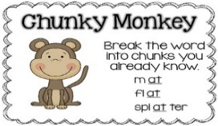  Watch the Chunky Monkey video  Watch the Chunk It video  Now find 3 unknown words in a book. Use chunking to help you figure out the word. | Help your parents make the grocery list for the week. Write down what you need and then read the list back to your parent.
Teach someone how to play the math game Make 10.  You will need a deck of cards or make cards with the numbers 0 through 10 (make 3 of each number).  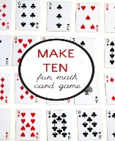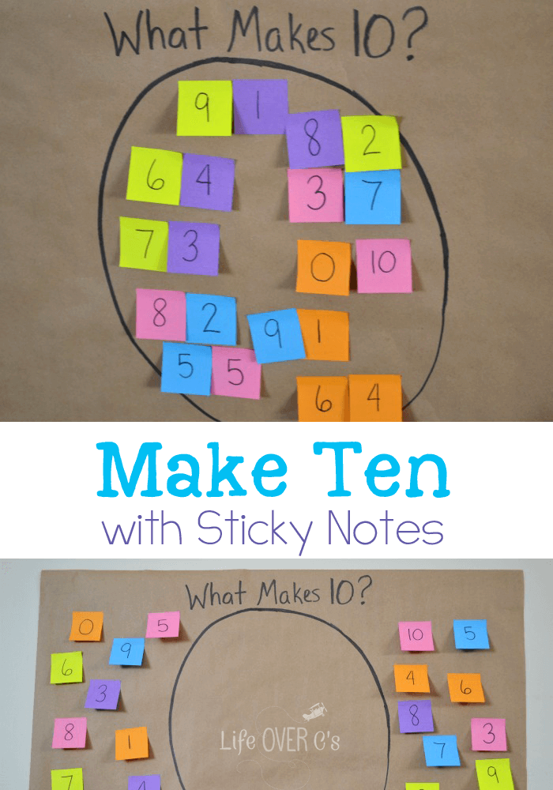 | 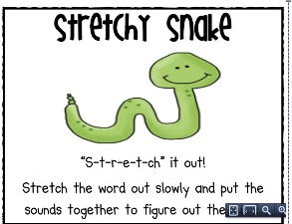  Watch the video  Now find 3 unknown words in a book. Use stretching it out to help you figure out the word. | Make a mini poster to tell how to save energy.  (remember the challenge we were doing at school. Hour without power, recycle, walk instead of drive)  Watch the Energy video
Listen to the story  The Tiger Who Came to Tea  Now retell the story to a family member | Listen and read along to the story:  The Caterpillar and the Polliwog  After watching, think about what your favorite part was. | Draw a picture of your favorite part of the story.  Write 2 or 3 sentences about your picture.
Continue to use Headsprout and Raz-kids
Practice sight words or spelling words. Read for at least 15 min each day.

