Grade 1 Literacy Activities: May 25-29
Use Headsprout and try to complete 3 episodes during the week. (this is phonics work, which will help students with their reading)

Practice sight words or spelling words.

Read for at least 15 min each day.

Please send me a piece of your child’s writing each week. I will send feedback on what they have done well and what they could do to improve. (email me or message me on Class Dojo)

**This document has many, many active links to be viewed during the daily lessons. It would be best to use an active, online copy for day-to-day use, either via your email attachment or on https://missorchardsclass.weebly.com/

*** If you can print it and stick it on your fridge or bulletin board. Have your child check off each day, once completed. That way if you miss a day, you know where you left off.

It is my hope you find this helpful. Please keep in mind that this is not meant to be a burden and put any added pressure on your day-to-day routines. It is only being made available for those who wish to make use of it. If you have any questions, please let me know.

Have fun!

Tic-Tac-Toe Board
Try and complete 3 activities during the week to get a horizontal, vertical or diagonal line.

Challenge: see how many of these activities you can do this week.

Speaking & Listening | Reading | Writing
Choose a story to read or listen to.  - Create a different ending.  - Tell a family member your new ending. | Two vowels go walking  watch video here  Read these words to a family member:  tie brain boat  steam rain float  beat stain coat | Rhyming Words  write 3 words that rhyme with these words:  lick pop yell
Compare and Contrast  Chose 2 favorite things.  (snacks, toys, tv shows, etc.)  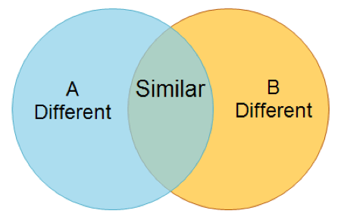 | Read a book on Raz-kids. Before you start, press the record button. Now your teacher will be able to listen to it. | -ing Word Family  video  How many words can you print that belong in the –ing word family? Remember words in a words family have the same ending, just the beginning sound changes.  Can you print at least 5?  How about more than 5?
Listen to the story  Ice Cream Summer  video here  Retell the story to a family member. Remember to tell what happened at the beginning, middle and end. | Syllables  watch video here  Now read these words and clap out the syllables. How many syllables does each word have?  brother running  after about  swim because  camper paper | What is your favorite flavor of ice cream?  Draw a picture of you enjoying you favorite ice cream flavor and then write about it. Why is it your favorite?  Here is a video on How to Make Your Own Ice Cream.

