Grade 1 Math Activities: May 11-15
- Continue to spend 10-15 minutes practicing math on Splash Learn

Tic-Tac-Toe: this week try and complete 3 activities to get a horizontal, vertical or diagonal line.
Challenge: see how many of these activities you can do this week.

Number & Operations | Shape & Space | Patterns & Relations
Doubles Facts (2 min)  watch video here  How many doubles facts can you answer?  Can you answer them out of order?  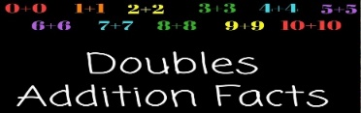 | Watch this 3D shapes video.  Look around your house can you find a cube, cone, cylinder and sphere?  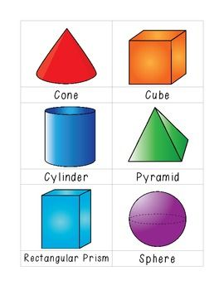 | Watch this video on repeating patterns.  Try and complete the patterns before the video tells you.  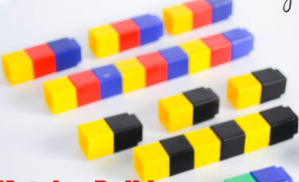
Make 10 (9 min)  watch video here  Practice sheets to go with video (Day 2 sheets-just scroll down to the correct day)  get worksheets here | Measurement  Find:  - 2 things that are about as long as your arm  - 2 things that are shorter than your arm  - 2 things that are longer than your arm.  Explain to someone in your house how you know. | Show someone in your house how to make an AAB pattern and an ABCD pattern. Remember to circle the core (the part that repeats).  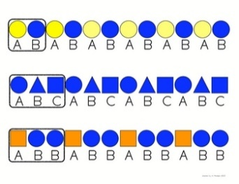
Ordering numbers  Write these numbers on squares of paper and put them in order from least (smallest) to greatest (biggest)  15, 23, 9, 84, 66, 2, 89,  36, 57, 19, 95, 71, 42, 38 | Measurement  Find 5 things and put them in order based on weight from heaviest to lightest.  Take the heaviest thing and find 3 things that weigh less. Tell someone in your house how you know. | Look for objects inside or outside to create a repeating pattern.  