Grade 1 Math Activities: May 18-22

- Continue to spend 10-15 minutes practicing math on Splash Learn

- Tic-Tac-Toe: this week try and complete 3 activities to get a horizontal, vertical or diagonal line.
Challenge: see how many of these activities you can do this week.

- **This document has many, many active links to be viewed during the daily lessons. It would be best to use an active, online copy for day-to-day use, either via your email attachment or on https://missorchardsclass.weebly.com/

- *** If you can print it and stick it on your fridge or bulletin board. Have your child check off each day, once completed. That way they know which ones they have completed.

- It is my hope you find this helpful. Please keep in mind that this is not meant to be a burden and put any added pressure on your day-to-day routines. It is only being made available for those who wish to make use of it. If you have any questions, please let me know.

- Have fun!

Another great math practice site: https://nb.mathgames.com/ (NB curriculum) scroll down to select grade level

Grade 1 Math Activities: May 18-22
Tic-Tac-Toe: this week try and complete 3 activities to get a horizontal, vertical or diagonal line.
Challenge: see how many of these activities you can do this week.

Number & Operations | Shape & Space/Number | Patterns & Relations
Number of the Day  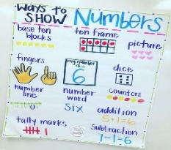  Choose a number between 1 and 20 and make a poster showing that number in different ways. How many ways can you think of? | Watch this 2D shapes video.  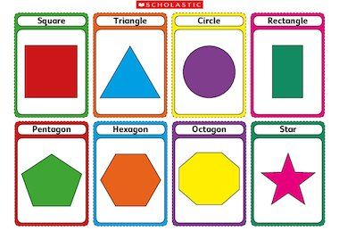  Look around your house or go for a walk around your neighborhood. What shapes did you see? | Exercise Patterns  watch video here  Game #1  Game #2
Make 10 (10 min)  watch video here  Practice sheets to go with video  (Day 3 sheets-just scroll down to the correct day)  get worksheets here | Count out 15 items  (blocks, coins, goldfish crackers, Legos, etc.)  How can you check that you have 15 items without counting by 1? | Using actions and sounds to make up your own repeating pattern.  Example: clap 2 times, stomp your feet, turn around.  How many different patterns can you make?
Adding  Find a partner and a deck of cards. Each player flips over a card. Find the sum.  Challenge:  What is 1 more, 2 more than the sum?  What is 1 less, 2 less than the sum?  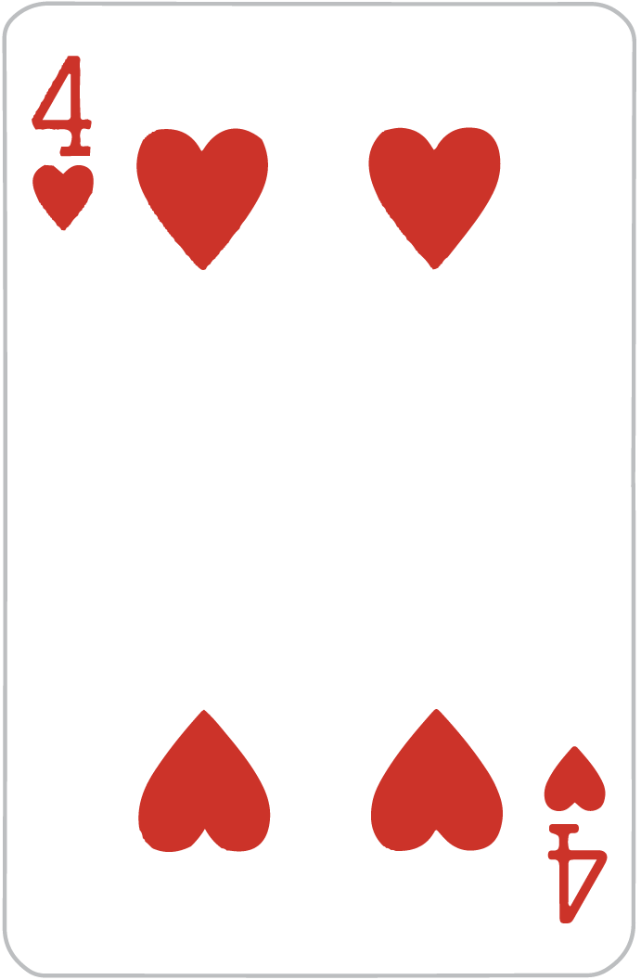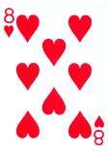 | Guess My Number  In this activity, players guess each other’s number.  1. Decide the range of numbers you will use, 1-10, 1-20, 1-50 or 1-100. You may want to write down the number or print of a 100 chart (for 1-50 or 1-100) for your child to use.  2. Your child will try to guess your number. After each guess, tell them whether the number is greater or less than their guess.  3. Your child can use the number line or 100 chart to cross out numbers after each guess. | Look at the number patterns below. Can you find the errors?  4, 14, 24, 34, 54, 64  65, 60, 55, 45, 40, 35  15, 20, 30, 35, 40, 45  90, 80, 70, 50, 40, 30  14, 16, 20, 22, 24, 26

