Grade 1 Math Activities: May 25-29

- Continue to spend 10-15 minutes practicing math on Splash Learn

- Tic-Tac-Toe: this week try and complete 3 activities to get a horizontal, vertical or diagonal line.
Challenge: see how many of these activities you can do this week.

- **This document has many, many active links to be viewed during the daily lessons. It would be best to use an active, online copy for day-to-day use, either via your email attachment or on https://missorchardsclass.weebly.com/

- *** If you can print it and stick it on your fridge or bulletin board. Have your child check off each day, once completed. That way they know which ones they have completed.

- It is my hope you find this helpful. Please keep in mind that this is not meant to be a burden and put any added pressure on your day-to-day routines. It is only being made available for those who wish to make use of it. If you have any questions, please let me know.

- Have fun!

Another great math practice site: https://nb.mathgames.com/ (NB curriculum) scroll down to select grade level

Grade 1 Math Activities: May 25-29
Tic-Tac-Toe: this week try and complete 3 activities to get a horizontal, vertical or diagonal line.
Challenge: see how many of these activities you can do this week.

Fact Families  watch video here  Roll 2 dice and find the sum. Write 2 addition and 2 subtraction equations to complete the fact family for this set of numbers.  ex. If you roll a 1 and 6 the sum is 7 so the fact family is 1+6=7 6+1=7  7-1=6 7-6=1 | Addition Word Problems  watch video here  After watching the video make up your own word problem. Draw a picture and write a number sentence to go with it.  Share your word problem with a family member. | Counting Forward  Start with 0-20 and then go higher. The goal is to count to 100.  Also practice counting forward between 2 given numbers. (start at 34 and count to 57).  For added fun count while throwing a ball back and forth with a partner.
Patterns  Outside use chalk or a stick to draw a repeating pattern using shapes. Do an action when you jump on each shape.  ex. diamond= jump, oval= clap, hexagon=spin | Number Words  watch video here  Students need to be able to read the numbers 1-20 in written form.  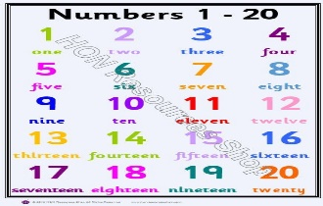 | Number Word Memory Game  Make a set of cards with the numbers 1-20 and another set of cards with the written word for the numbers.  Match the symbolic for with the written form.  8 eight
Counting Backward  Practice counting backwards. Start with 20-o and then go higher. Aim to count backwards from 100.  Also practice counting forward between 2 given numbers. (start at 34 and count to 57).  For added fun count while throwing a ball back and forth with a partner. | Number of the Day  Choose a number between 1 and 20 and make a poster showing that number in different ways. How many ways can you think of?  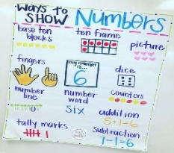 | Counting  Use tally marks to count objects inside or outside your house.  Possible objects:  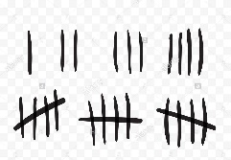  - shoes  - blocks  - stuffies  - rocks

