Grade 1 Math Activities: June 1-5

- Continue to spend 10-15 minutes practicing math on Splash Learn

- Tic-Tac-Toe: this week try and complete 3 activities to get a horizontal, vertical or diagonal line.
Challenge: see how many of these activities you can do this week.

- **This document has many, many active links to be viewed during the daily lessons. It would be best to use an active, online copy for day-to-day use, either via your email attachment or on https://missorchardsclass.weebly.com/

- *** If you can print it and stick it on your fridge or bulletin board. Have your child check off each day, once completed. That way they know which ones they have completed.

- It is my hope you find this helpful. Please keep in mind that this is not meant to be a burden and put any added pressure on your day-to-day routines. It is only being made available for those who wish to make use of it. If you have any questions, please let me know.

- Have fun!

Another great math practice site: https://nb.mathgames.com/ (NB curriculum) scroll down to select grade level

Grade 1 Math Activities: June 1-5
Tic-Tac-Toe: this week try and complete 3 activities to get a horizontal, vertical or diagonal line.
Challenge: see how many of these activities you can do this week.

Mental Math Strategies  watch video here  Relation of addition & subtraction  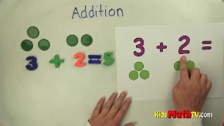 | Skip Counting  Count by 2s, 5s and 10s to 100.  Use this interactive 100 chart and look for the patterns.  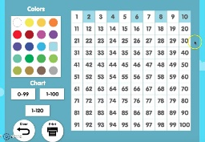  Try counting backwards for a challenge. | Writing Numbers  You will need to find a family member and paper and pencil.  Have your partner say any number between 1 and 100.  - Can you write it down?  - Make sure your numerals are in the correct place.
Counting On Strategy  watch video here  Counting Back Strategy  watch video here | Counting on/back strategy  materials:  - objects for counting (coins, Lego, buttons, goldfish crackers)  - piece of paper or cup  Place a known amount of counters under the paper or cup (8-20) and more counters beside the paper or cup. Ask your child how many counters altogether? Does your child use the counting on strategy? Try different quantities. | Make 10  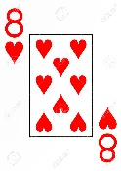  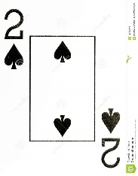  Use a deck of cards with the face cards removed and play Making 10 Go Fish. (if you have a 2 you ask for an 8 to make 10)
1 more/2 more and 1 less/2 less  2 less 1 less number 1 more 2 more  6  11  17  Try and do it with numbers larger than 20. | Subitizing  Instantly recognizing how many are in a set of items.  watch video here  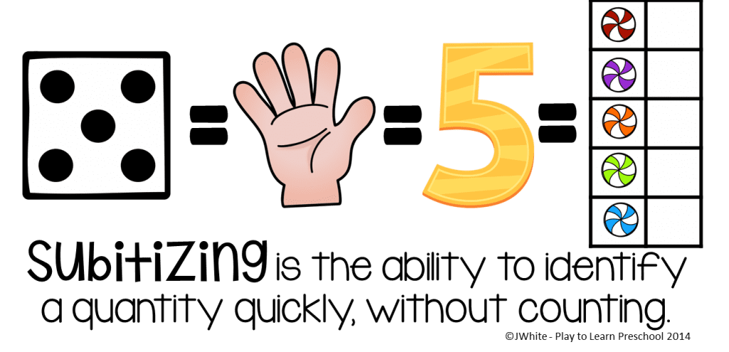 | Number of the Day  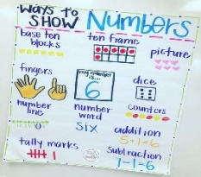  Choose a number between 11 and 20 and make a poster showing that number in different ways. How many ways can you think of?

