Grade 2 Literacy Activities: May 11-15
Tic-Tac-Toe: this week try and complete 3 activities
to get a horizontal, vertical or diagonal line.

Challenge: see how many of these activities you can do this week.

Speaking & Listening | Reading | Writing
Watch this Fact and Opinion video  Which is better ice cream or pizza?  Tell why your choice is better. | 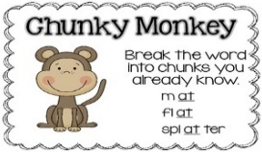  Watch the Chunky Monkey video  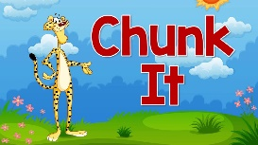  Watch the Chunk It video  Now find 3 unknown words in a book. Use chunking to help you figure out the word. | Watch this persuasive writing video  Tell me why you should go to grade 3.  - Beginning telling what your writing about  - middle – 4 reasons why  - ending  - Use first, then, next, finally.
Compare and Contrast  think of your 2 favourite toys or snack. Tell someone how they are the same and how they are different. | Read a book on Raz-kids. Before you start, press the record button. Now you teacher will be able to listen to it.  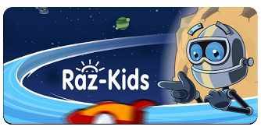 | Make a mini poster to tell how to save energy.  (remember the challenge we were doing at school. Hour without power, recycle, walk instead of drive)  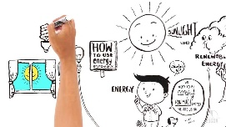  Watch the Energy video
Read or listen to a book of your choice. Create a new ending. Tell someone in your family your new ending.  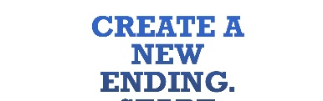 | Listen and read along to the story:  Mabel Murple  read by author Sheree Fitch | Write your own tongue twister.  Have someone in your house read it 3 times.
Continue to use Headsprout and Raz-kids
Practice sight words or spelling words. Read for at least 15 min each day.

