Grade 2 Literacy Activities: June 1-5
Use Headsprout and try to complete 3 episodes during the week. (this is phonics work, which will help students with their reading)

Practice sight words or spelling words.

Read for at least 15 min each day.

Please send me a piece of your child’s writing each week. I will send feedback on what they have done well and what they could do to improve. (email me or message me on Class Dojo)

**This document has many, many active links to be viewed during the daily lessons. It would be best to use an active, online copy for day-to-day use, either via your email attachment or on https://missorchardsclass.weebly.com/

*** If you can print it and stick it on your fridge or bulletin board. Have your child check off each day, once completed. That way if you miss a day, you know where you left off.

It is my hope you find this helpful. Please keep in mind that this is not meant to be a burden and put any added pressure on your day-to-day routines. It is only being made available for those who wish to make use of it. If you have any questions, please let me know.

Have fun!

Grade 2 Literacy Activities: June 1-5
Tic-Tac-Toe Board
Try and complete 3 activities during the week to get a horizontal, vertical or diagonal line.

Challenge: see how many of these activities you can do this week.

Speaking & Listening/Reading |  | Reading | Writing
Silent letter  watch video here  Now read or listen to a story and watch for words with silent letters. |  | Making predictions  watch video here  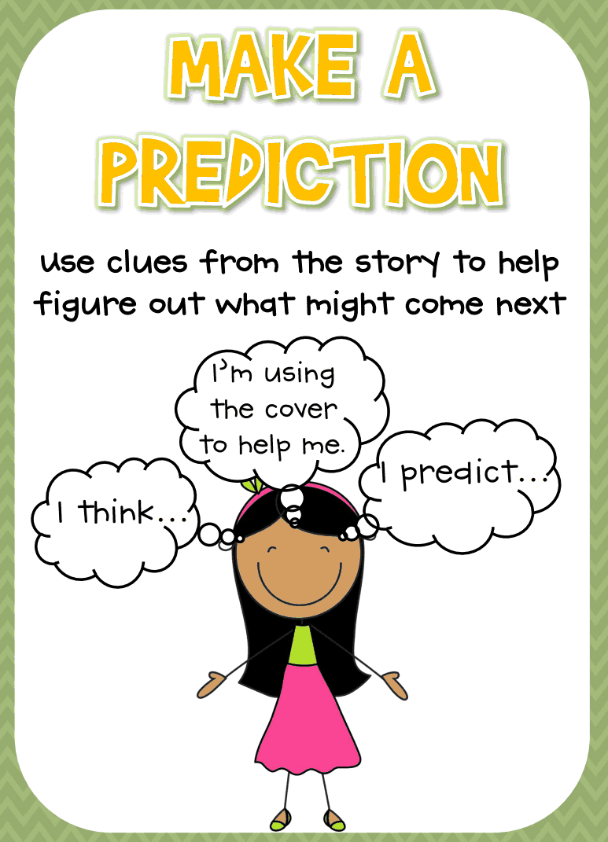 | Informational Writing  (non-fiction)  episode 1 (1 min 40 sec)  episode 2 (2 min 12 sec)  After watching the 2 videos  - brain storm some topics  - plan (printable planning paper KWL chart)  I’m looking forward to learning something new from you research paper.
Nouns & Verbs |  | Read a book on Raz-kids. Before you start, press the record button. Now your teacher will be able to listen to it.  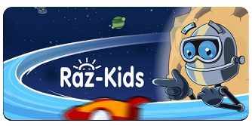 | Informational Writing  (non-fiction)  episode 3 (4 min 21 sec)  Now it’s time to do some research on your topic so you can fill in your Know, Wonder, Learned charts.
watch video here  game 1  game 2 (click  number 1) | watch video here  game 1 (do red  highlighted option)  game 2
3 letter blends  watch video here  Can you read these words?  spring shrimp  split straw  scrub thrill |  | Adjectives  watch video here  game 1  game 2 (click number 1 but you can do more after if you wish) | Informational Writing  (non-fiction)  Continue to research your topic so you can fill in your Know, Wonder, Learned charts.  You will learn more next week about writing your report.  **two more episodes next week
Informational Writing build on each other so they need to be followed in order.
I’m looking forward to learning something new from you research paper.

