Grade 2 Literacy Activities: June 8-12
Use Headsprout and try to complete 3 episodes during the week. (this is phonics work, which will help students with their reading)

Practice sight words or spelling words.

Read for at least 15 min each day.

Please send me a piece of your child’s writing each week. I will send feedback on what they have done well and what they could do to improve. (email me or message me on Class Dojo)

**This document has many, many active links to be viewed during the daily lessons. It would be best to use an active, online copy for day-to-day use, either via your email attachment or on https://missorchardsclass.weebly.com/

*** If you can print it and stick it on your fridge or bulletin board. Have your child check off each day, once completed. That way if you miss a day, you know where you left off.

It is my hope you find this helpful. Please keep in mind that this is not meant to be a burden and put any added pressure on your day-to-day routines. It is only being made available for those who wish to make use of it. If you have any questions, please let me know.

Have fun!

Grade 2 Literacy Activities: June 8-12
Tic-Tac-Toe Board
Try and complete 3 activities during the week to get a horizontal, vertical or diagonal line.

Challenge: see how many of these activities you can do this week.

Speaking & Listening/Reading | Reading | Writing
Make up a campfire story and then find a partner and tell them your story. | Listen to  A Campfire Tale  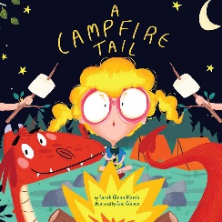  Before reading the book tell someone what you predict will happen. After listening tell what actually happened. | Informational Writing (non-fiction)  episode 4 (3 min 42 Sec)  Now it’s time for you to take the information from your planning and put it in sentences. Remember to use headings.  I’m looking forward to learning something new from you research paper.)
Bossy ‘R’  watch video here  game  Challenge: How many bossy ‘R’ words came you write? | Read a book on Raz-kids. Before you start, press the record button. Now your teacher will be able to listen to it. | Informational Writing (non-fiction)  episode 5 (4 min 8 sec)  Use what you learned in this episode and revise your paper.  I’m looking forward to learning something new from you research paper.
Parts of a sentence  watch video here  Explain to someone the parts of a sentence.  Write 2 complete sentences. | Listen to  The Night Before Summer Vacation  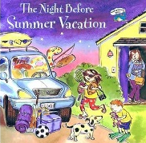  Explain to an adult what these words mead:  anticipation (0:11 sec)  swell (1:20)  clatter (2:30) | Write about what you hope to do this summer. What fun things are you going to do?  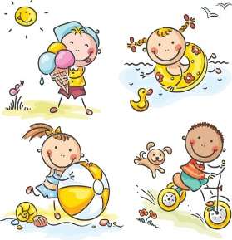
Informational Writing build on each other so they need to be followed in order.
I’m looking forward to learning something new from you research paper.

