Grade 2 Literacy Activities: May 18-22
Use Headsprout and try to complete 3 episodes during the week. (this is phonics work, which will help students with their reading)

Practice sight words or spelling words.

Read for at least 10-15 min each day.

Please send me a piece of your child’s writing each week. I will send feedback on what they have done well and what they could improve. (email me or message me on Class Dojo)

**This document has many, many active links to be viewed during the daily lessons. It would be best to use an active, online copy for day-to-day use, either via your email attachment or on https://missorchardsclass.weebly.com/

*** If you can print it and stick it on your fridge or bulletin board. Have your child check off each day, once completed. That way if you miss a day, you know where you left off.

It is my hope you find this helpful. Please keep in mind that this is not meant to be a burden and put any added pressure on your day-to-day routines. It is only being made available for those who wish to make use of it. If you have any questions, please let me know.

Have fun!

Grade 2 Literacy Activities May 18-22

Tic-Tac-Toe Board: try and complete 3 activities during the week to get a horizontal, vertical or diagonal line.

Challenge: see how many of these activities you can do this week.

Speaking & Listening | Reading | Writing
Listen to the story  Please Please the Bees  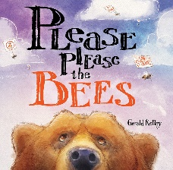  After listening tell someone in your family the problem and solution in the story and explain how the character(s) work to solve the problem. | Watch this video about when 2 vowels are together in a word.  2 Vowels go Walking  Now read a book and look for words that have 2 vowels together, with the first one doing the talking. | Procedural (How To) Writing  episode 1  episode 2  After watching the 2 videos pick a topic and write your introduction. (Keep this for the next part below)
Teach someone in your family how to play the math game Make 10.  You will need a deck of cards for this. | Read a book on Raz-kids. Before you start, press the record button. Now you teacher will be able to listen to it. | Procedural Writing continued  episode 3  After watching the video write add the steps to your introduction.
Watch this video, How to Make a Peanut Butter Sandwich.  After watching, explain to someone how to make a sandwich using transition words.  First  Next  Then  Finally | 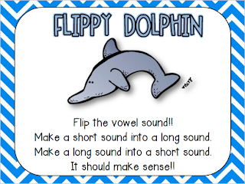  watch the Flippy Dolphin video  Now go read a book and try Flippy Dolphin when you come to a word you don’t know | Write and tell me how you feel about not being at school.  -Do you miss being at school?  -Do you like being home?

