Grade 2 Literacy Activities: May 25-29
Use Headsprout and try to complete 3 episodes during the week. (this is phonics work, which will help students with their reading)

Practice sight words or spelling words.

Read for at least 15 min each day.

Please send me a piece of your child’s writing each week. I will send feedback on what they have done well and what they could do to improve. (email me or message me on Class Dojo)

**This document has many, many active links to be viewed during the daily lessons. It would be best to use an active, online copy for day-to-day use, either via your email attachment or on https://missorchardsclass.weebly.com/

*** If you can print it and stick it on your fridge or bulletin board. Have your child check off each day, once completed. That way if you miss a day, you know where you left off.

It is my hope you find this helpful. Please keep in mind that this is not meant to be a burden and put any added pressure on your day-to-day routines. It is only being made available for those who wish to make use of it. If you have any questions, please let me know.

Have fun!

Tic-Tac-Toe Board
Try and complete 3 activities during the week to get a horizontal, vertical or diagonal line.

Challenge: see how many of these activities you can do this week.

Speaking & Listening | Reading | Writing
I went to the shops…  This is a great game to challenge your child’s listening and memory skills.  - One child starts off the shopping list by saying “I went to the shops today and bought…” (something).  - The next child continues by saying the previous item and adding their own item!  - See how many items you can say before something is forgotten. | Reading Strategy  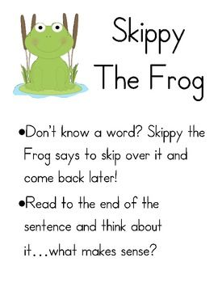  Now go read a book and use Skippy the Frog when you come to a word you don’t know. | If you could have any secret super power, what would you want it to be and why?  (give at least 3 reasons)
Find a partner. Tell your partner about your favorite season then listen to your partner tell you their favorite season.  Remember to give reasons why it’s your favorite. | Read a book on Raz-kids. Before you start, press the record button. Now your teacher will be able to listen to it. | Have you ever read a book written by Dr. Suess?  Write your own “Suess-style” story, complete with rhymes and made up words
Listen to the story  Ice Cream Summer  video here  Retell the story to a family member. Remember to tell what happened at the beginning, middle and end. | Syllables  watch video here  Now read these words and clap out the syllables. How many syllables does each word have?  swimming sunny  trampoline away  summer campfire  children elephant | What is your favorite flavor of ice cream?  Draw a picture of you enjoying you favorite ice cream flavor and then write about it. Why is it your favorite?  Here is a video on How to Make Your Own Ice Cream.

