Grade 2 Math Activities: June 1-5

- Continue to spend 10-15 minutes practicing math on Splash Learn

- Tic-Tac-Toe: this week try and complete 3 activities to get a
horizontal, vertical or diagonal line.
Challenge: see how many of these activities you can do this week.

- **This document has many, many active links to be viewed during the daily
lessons. It would be best to use an active, online copy for day-to-day
use, either via your email attachment or on https://missorchardsclass.weebly.com/

- *** If you can print it and stick it on your fridge or bulletin board. Have
your child check off each day, once completed. That way they know which
ones they have completed.

- It is my hope you find this helpful. Please keep in mind that this is not meant to
be a burden and put any added pressure on your day-to-day routines. It is only
being made available for those who wish to make use of it. If you have any
questions, please let me know.

- Have fun!

Another great math practice site: https://nb.mathgames.com/ (NB curriculum) scroll
down to select grade level

Grade 2 Math Activity Board: June 1-5
This week try and complete 3 activities.
Challenge: see how many of these activities you can do this week.
Comparing Numbers to 100  watch video here  Have a family member write 4 or 5 numbers down in random order. Now order the numbers in ascending order.  Repeat and put in descending order. | Measurement  Length: Why would measuring a table in the breakfast room with a shoe string give you a different measurement than using a paper clip?  Mass: What would you use to measure the mass of a watermelon, snap cubes or wooden blocks?  What would you use to measure the length of your bed?  Explain your thinking to an adult. | Describe the given 2-digit numeral in at least two ways.  Number Tens and ones New Grouping  37 Tens Ones 7 3 Tens Ones 17 2  63 Tens Ones Tens Ones  42 Tens Ones Tens Ones  91 Tens Ones Tens Ones  78 Tens Ones Tens Ones
Number of the Day  Choose a number between 61 and 100 and make a poster showing that number in different ways. How many ways can you think of?  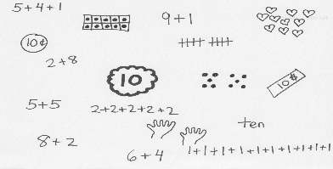 | Number Balances  watch video here  game 1  game 2 | Patterns  Describe the following double attribute patterns to someone at your house.
Counting  Start at 14 and count by 10s as high as you can (don’t go past 500)  Challenge: can you print the numbers as you say them up to 100 | Using the number 23 make up an addition story problem that includes that number. Remember to write the number sentence that matches the problem.  Can you make up another story problem but use the number 23 in a different way? | Patterns  Explain how these patterns are alike and how they are different.

