Grade 2 Math Activities: May 11-15
Tic-Tac-Toe: this week try and complete 3 activities to get a horizontal, vertical or diagonal line.
Challenge: see how many of these activities you can do this week.

Number & Operations | Shape & Space | Patterns & Relations | Data
Ordering numbers  1. Write these numbers below  on squares of paper  2. put them in descending order  3. mix them up and put them in  ascending order  Use a hundred chart to see of you are correct.  15, 23, 9, 84, 66, 2, 89,  36, 57, 19, 95, 71, 42,38 | Watch this  3D shapes video.  Look around your house and try to find a cube, cone, cylinder, sphere, and rectangular prism?  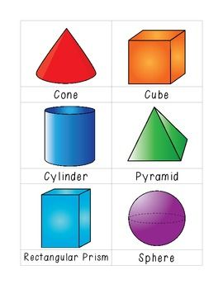 | Watch the following video on  repeating patterns and their attributes  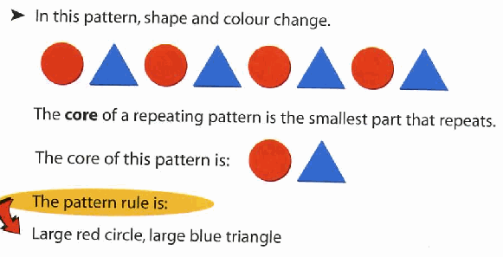 | Watch this video on  creating a bar graph  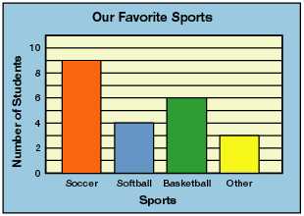  Watch this video on  creating picture graphs  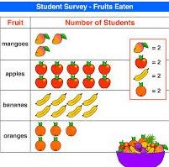
Make 10 (9 min)  watch video here  Practice sheets to go with video (Day 2 sheets-just scroll down to the correct day)  get worksheets here | Calendar  - Write today’s date.  - What was yesterday’s date?  - What will the date be tomorrow?  - What was last month?  - What will next month be? | Look for objects inside or outside to create a repeating pattern with 3-5 elements. Tell someone in your family the core of your pattern. | Think of a question that will help you gather information about the people in your family. Now go and ask your question and collect your data  *remember to organize your data neatly in a simple table or using tally marks.
With a partner use a deck of cards.  1. Each player flips over 2  cards and makes a 2-digit  number.  2. What is 1 more, 2 more than  your number?  3. What is 1 less, 2 less than  your number? | Measurement  Find 5 things and put them in order based on mass (weight) from heaviest to lightest.  Take the heaviest thing and find 3 things that have a mass less than it. Tell someone in your house how you know. | Watch these 2 increasing (growing) and decreasing (getting smaller) pattern videos  1. increasing (growing) patterns  2. increasing & decreasing patterns  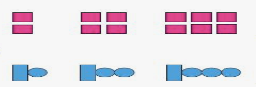  After watching the videos try and make your own growing pattern. Save it and we’ll discuss them during our grade 2 meeting on Thursday | Take your data and make a bar graph and then a picture graph.

