Grade 2 Math Activities: May 18-22

- Continue to spend 10-15 minutes practicing math on Splash Learn

- Tic-Tac-Toe: this week try and complete 3 activities to get a horizontal, vertical or diagonal line.
Challenge: see how many of these activities you can do this week.

- **This document has many, many active links to be viewed during the daily lessons. It would be best to use an active, online copy for day-to-day use, either via your email attachment or on https://missorchardsclass.weebly.com/

- *** If you can print it and stick it on your fridge or bulletin board. Have your child check off each day, once completed. That way they know which ones they have completed.

- It is my hope you find this helpful. Please keep in mind that this is not meant to be a burden and put any added pressure on your day-to-day routines. It is only being made available for those who wish to make use of it. If you have any questions, please let me know.

- Have fun!

Another great math practice site: https://nb.mathgames.com/ (NB curriculum) scroll down to select grade level

Grade 2 Math Activity Board: May 18-22
Tic-Tac-Toe: this week try and complete 3 activities to get a horizontal, vertical or diagonal line.
Challenge: see how many of these activities you can do this week.

Number & Operations | Shape & Space | Patterns & Relations | Data/Number
Pace Value  Make a given number with base 10 blocks game  (select read & make then go back and select count & write) | Calendar  reading a calendar  game 1  game 2 | Equality & Inequality  watch video here  addition game  subtraction game | Interpreting bar graphs  game 1  game 2  game 3 (level 1)
Mental Math Strategy  watch these videos on  Building on a Known Double  &  Doubles plus 1 and plus 2 | Measurement (length)  Choose something to measure the length of and an object to use as a non-standard unit (see below) of measure.  1. Estimate how many units long you  think it will be.  2. Measure and find out.  3. Was your estimate a good one? | Fill in the blanks to make the statements true. Explain your thinking to a family member.  7 + ____ = 2 + 2 + 2 + 2  16 – 8 ≠ 4 + ____  8 + 3 ≠ 17 – ____  14 = 3 + ____ + 7 | Interpreting picture graphs  game 1  game 2  game 3
Number of the Day  Choose a number between 21 and 50 and make a poster showing that number in different ways. How many ways can you think of?  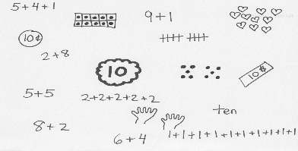 | Measurement (height)  Choose something to measure the height of and an object to use as a non-standard unit (see below) of measure.  1. Estimate how many units tall you  think it will be.  2. Measure and find out.  3. Was your estimate a good one? | What is missing from the following increasing patterns:  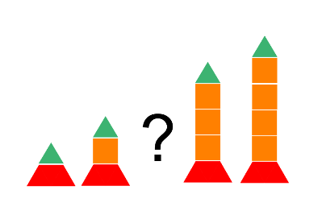  6, 16, 26, __, 46, __, __, 76  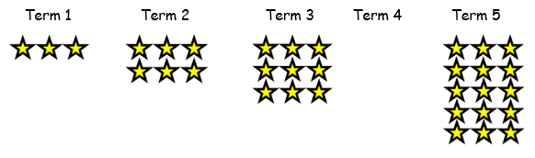 | Creating Story Problems  Write a story problem for the following number sentences then solve the problem.  16 – 24 =  48 - 14 =

