Grade 2 Math Activities: May 25-29

- Continue to spend 10-15 minutes practicing math on Splash Learn

- Tic-Tac-Toe: this week try and complete 3 activities to get a horizontal, vertical or diagonal line.
Challenge: see how many of these activities you can do this week.

- **This document has many, many active links to be viewed during the daily lessons. It would be best to use an active, online copy for day-to-day use, either via your email attachment or on https://missorchardsclass.weebly.com/

- *** If you can print it and stick it on your fridge or bulletin board. Have your child check off each day, once completed. That way they know which ones they have completed.

- It is my hope you find this helpful. Please keep in mind that this is not meant to be a burden and put any added pressure on your day-to-day routines. It is only being made available for those who wish to make use of it. If you have any questions, please let me know.

- Have fun!

Another great math practice site: https://nb.mathgames.com/ (NB curriculum) scroll down to select grade level

Grade 2 Math Activity Board: May 25-29
This week try and complete 3 activities.
Challenge: see how many of these activities you can do this week.

Mental Math Strategies | Number | Shape & Space | Patterns
watch these videos on  Bridging through 10  &  Make 10 | Even/Odd  Use a deck of cards or paper squares with the numbers 0 through 9 printed on them.  1. Flip over 2 cards and make a 2 digit number.  2. Is the number you made even or odd  3. use concrete materials or a picture to show how you know. | 2D shape attributes  watch video here  Look for objects around your house that are made up of squares, circles, rectangles and triangles | Fill in the blanks to make the statements true. Explain your thinking to a family member.  9 + 2 = 3 + 5 + ___  19 – 2 - 7 ≠ ___ + 4  ___ + 3 ≠ 18 – 5  27 = 3 + ___
Using Addition to Subtract  for Word Problems  watch video here  practice worksheet attached below | Creating Story Problems  Write an addition story problem and number sentence. The answer to your problem must be 46.  Write a subtraction story problem and number sentence. The answer to your problem must be 12. | 3D object attributes  watch this video about  how to describe 3D shapes  Look for 3D objects around your house | Number Pattern Rules  video here  game 1  game 2  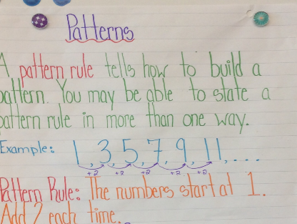
Fact Family  watch video here  Use the following set of numbers to make fact families.  7, 13, 6 17, 14, 31  45, 29, 16 19, 7, 26 | Ordinal Numbers  watch video here  Line up a few of you toys or other objects and use ordinal numbers to tell a family member the position of each one. | Sort the 2D shapes according to 2 attributes and explain your sorting rule  2D  Sort the 3D objects according to 2 attributes and explain your sorting rule  3D | Double Attribute Pattern  watch video here  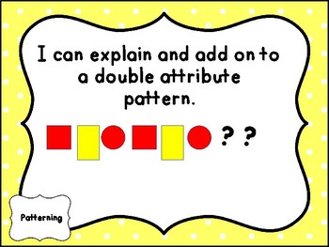  Now make 2 of your own double attribute pattern?
